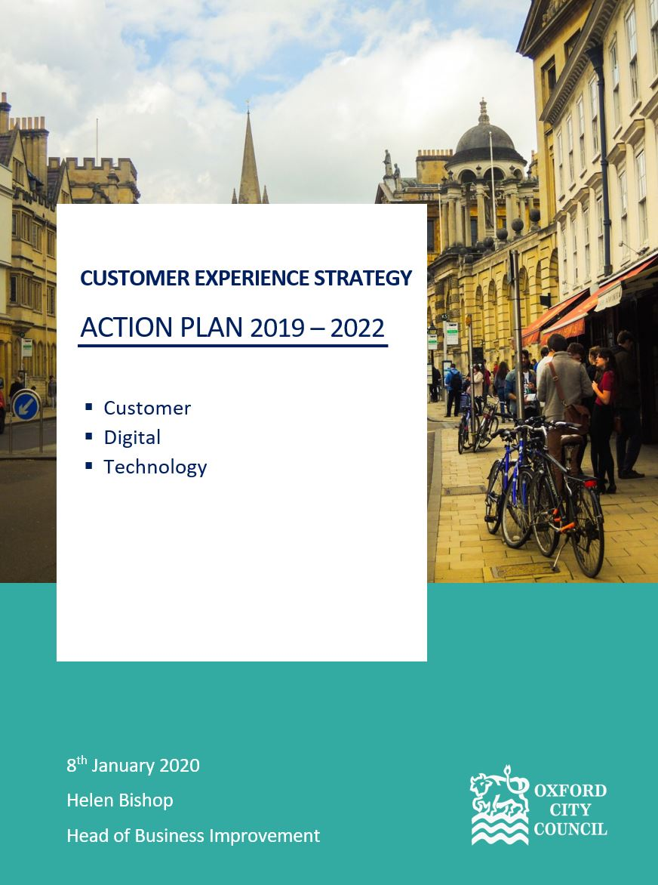
Appendix 1
Contents
The Vision 3
The Objectives 3
A Great Customer Experience 3
Building Skills and Capabilities 3
Technology that Enables More Collaborative and Flexible Working 3
Modern, Consolidated Systems for Data-Driven Decision Making 3
Where is the Council Today? 4
Facts and Figures 4
What Communities and Customers Say 4
The Financial Case 5
What Are The Gaps? 6
From a Customer Perspective 6
From a Staff Perspective 6
From a Digital Perspective 6
From a Technology Perspective 6
The Outcomes and Action Plan 7
A Summary of the Benefits 8
The Action Plan Timeline and Costs 9
References 11

The Vision
The Customer Experience Strategy brings together the Customer, Digital and Technology strategies and is designed to make a difference in the places where it matters the most, putting customers at the heart of everything the Council does. The strategy and associated action plan reflect how the Council intends to support the four aims of the Council Strategy 2020 - 2024, highlighting those initiatives that will directly and indirectly help deliver an improved customer experience.

The Objectives
In defining this vision and objectives this document draws on the Council’s corporate plan 2020 - 2024, including extensive consultation with directors, key Members, staff across all Service Areas, and customer groups, as well as taking into consideration government and industry best practice.
The purpose of the strategy is to realise the following:

A Great Customer Experience
Making every interaction count throughout the whole customer engagement, ensuring the Council commitment chimes with customers at every opportunity to improve accessibility through initiatives which promote equalities, and digital as the channel of choice for those customers who are able and prefer to help themselves, setting clear expectations, getting it right first time, providing holistic solutions to issues, collecting feedback and involving customers in service change and design.

Building Skills and Capabilities
Helping staff to be “change-makers” and giving them the power to act and resolve issues for the customer, their teams and themselves through customer and digital skills training, management development, embedding a positive culture and the right behaviours across the organisation, inviting feedback and engaging staff in the decision-making process.

Technology that Enables More Collaborative and Flexible Working
Helping staff to be more efficient and effective by providing the tools for smarter ways of working; having mobile devices that can be used in the field or at home; improving accessibility to the office network, lowering operating costs and reducing the Council carbon footprint. This will be achieved by replacing old equipment, improving security and communications, and offer a range of flexible alternative technology solutions to suit business needs and individual preferences.

Modern, Consolidated Systems for Data-Driven Decision Making
Modernising and consolidating business applications into fewer, more user-friendly ones and leveraging information to make more effective choices about what to do and where to focus Council resources, sharing that data with residents and communities so they can make informed decisions. Replacing and consolidating outdated software, including asset, document and case management systems, implementing a data and analytics strategy, providing the tools and resources, streamlining and joining up processes, with information sharing protocols, thereby enabling efficiencies.

Where is the Council Today?

Facts and Figures
The demands placed on Council services, and the levels of satisfaction achieved from a population of 155,000 residents, numerous businesses, and many more visitors to Oxford City, are reflected in the following statistics from 2018:
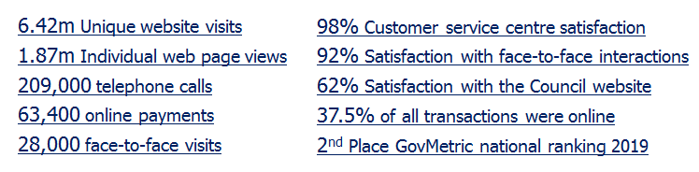
Note: GovMetric is a multi-channel solution, measuring customer satisfaction and gathering informal customer feedback used to inform service improvement and deliver customer excellence.

What Communities and Customers Say

A four-month consultation exercise took place between December 2018 and March 2019, involving residents and Council colleagues. The purpose was to engage in dialogue and gather as many perspectives from as wide an audience as possible. The process included face-to-face presentations and workshops, online surveys, and team meetings.
Numerous responses were received to internal and external surveys. Five resident workshops and three staff sessions were held during this period.
The most frequent comments made:
- Customer Experience
  - How staff interact with customers
  - The content and quality of the Council website
  - The need to adopt a clearly defined customer culture

- Staff Skills
  - The content and quality of the staff intranet
  - Customer and digital awareness and skills training
  - How staff can improve communication and collaboration

- The Right Technology
  - Having fit-for-purpose tools to do the job
  - Better use of technology to support smarter, mobile working

- Better Systems and Data
  - Fewer and more up-to-date business applications
  - The need for process improvements and more, clearer online services
  - More effective integration and use of customer data

The Financial Case

The financial case to move people to digital interaction is strong, with estimates of cost varying, but on average reflecting the following unit costs per transaction:
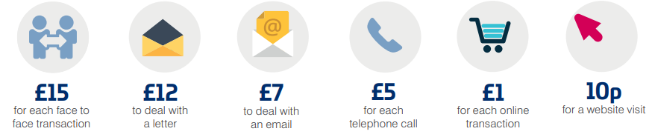
Note: Source is SOCITM (Society for IT practitioners in the public sector)
Whilst this strategy does not seek to reduce the availability or accessibility of face-to-face or telephony based services, improvements to the website and online presence should promote digital as the channel of choice for those that prefer to use it.
The premise is to ensure that there is customer choice for those that can help themselves to use digital channels, so there is more time and resource to provide assistance for more complex cases and more vulnerable members of the community, either in person or over the telephone.
The online offering must be at least as good as other channels, and customers must have a positive experience for each web visit and social media interaction. Failure to deliver a good service drives up the costs for the Council by pushing people to use more expensive means of contact. By the same token, improving the quality and quantity of digital services can help reduce the cost of delivering Council services.
All future proposals that arise from a series of discovery and feasibility reviews will be framed against the need to ensure the Council delivers value for money propositions.

What Are The Gaps?

From a Customer Perspective
- Customer insight shows a variable customer experience across the organisation, particularly in business-as-usual mode, as evidenced in customer journey mapping, desktop reviews, staff feedback and 3Cs (compliments, comments and complaints), with a long tail of open cases.
- There is a lack of identifiable proactive customer insight gathered which is not widely applied especially regarding comments and complaints.
- There is an inside-out approach to the design of services rather than two-way co-design with customers, understanding services from their perspective.
- Failure demand in service areas drives up customer contact in front of house and a fall in customer satisfaction.
- Delivering online accessibility is an on-going requirement as a result of changes in legislation, and to enhance existing services to provide full support for the Council equalities strategy.

From a Staff Perspective
- There needs to be a council-wide, customer-focused environment where staff and services are able to flourish and the culture is consistently one of putting the customer first.
- Many services have a silo approach to customer case resolution and process improvement. This is shown through the lack of a joined-up approach to process change and customer engagement.

From a Digital Perspective
- The design, quality and content of the Council website provide a poor customer experience.
- Online forms and the business processes behind them are complex and in many cases lack the mechanisms to keep customers updated on progress.

From a Technology Perspective
- Computers and mobile devices have a limited lifespan as new software and solutions place ever increasing demands on the technology. The great increase in Wi-Fi and broadband enabled services, and the need to work from any location, requires that investments are made in technology to keep pace with these advances. Work is already underway to deliver the needed improvements.
- Some of the Council’s key business applications are outdated systems, soon to be without support, providing duplicate or overlapping capabilities and information. As many of these systems date back several years they are not designed to work effectively in the modern, cloud-enabled world.
- A review of all asset, document and case management systems will be commissioned to identify opportunities to reduce cost and improve data quality. Following on from the review, it is anticipated that a number of the existing legacy systems will be replaced with fewer, more modern systems, providing opportunities for improved management of all Council assets.
- The Council’s ability to capture, extract, analyse, report and make informed decisions on the data collected is fragmented and inefficient, with a spreadsheet-driven approach to addressing these limitations. In some cases the same or similar data is stored across multiple systems.

The Outcomes and Action Plan
This strategy aims to deliver the following four outcomes:
Deliver a great customer experience:
- provide clear communication and information, helping people make informed decisions
- improve the quality, search capability and accessibility of the Council website
- ensure two-way dialogue with customers, being more consistent and responsive
- keep customers up-to-date on progress, setting and managing their expectations
- be open and transparent about what the Council does and its service standards
- measure the customer experience in a meaningful way to continuously improve services
- involve customers in the definition and improvement of new and existing services
- provide customers with choices on how they access services, whilst promoting digital up-take
- gather appropriate customer insight and then use it to inform service improvements
- redesign the most popular processes end-to-end to encourage customers to self-serve
- ensure customer-facing staff are kept informed of major Council initiatives
Build the skills and capabilities in the workforce:
- lead by example, walking the walk, talking the talk, and being consistent in what is said and done
- promote the values and culture we expect from each other
- role model great customer service behaviours
- provide staff with the digital and customer service skills needed to deliver great service
- involve staff in decision-making, in the design and improvement of services
- promote a culture of collaboration, measured risk taking, and no blame
- replace the intranet to make effective use of workplace information and online tools
- redevelop relevant policies helping staff to take decisions and work confidently
- improve the quality, search capability and accessibility of the Council’s intranet
Provide technology that enables collaboration:
- improve and extend existing Wi-Fi, internet bandwidth and remote access services
- replace old laptops, desktops and smartphones with newer models
- provide phone alternatives including softphones and “Bring Your Own Device”
- make audio-conferencing an effective option with additional tools and services
- provide video-conference solutions in offices and for remote access on computers
- introduce cloud-based (SaaS) software solutions for cost-effective collaboration
Implement modern systems for data-driven decision making:
- reduce the number of outdated systems to simplify access to information
- invest in the skills and capacity needed to integrate and perform analysis on data
- promote the use of meaningful measures as part of the decision-making process
- enable data sharing through information sharing protocols with other organisations
- publish open data through a new website to better support communities and businesses
- a holistic view of the customer, through the consolidation of systems and data

A Summary of the Benefits

Subject to business case approvals, funding and resources, the portfolio of projects and initiatives will deliver numerous benefits to communities, customers and the Council, including:

Public Benefits | Staff Benefits | Initiatives
 | Digital and business systems skills for staff | Digital Skills training, Business systems training
Digital skills for customers |  | Awareness workshops
Customer service skills for all Council staff |  | Training sessions
Improved online information and services for customers |  | Redesigned Internet, Mobile App & social media, with more, simplified online forms
 | Modern end user devices | Desktop computers, laptops, telephony solutions (smartphones, Bring Your Own Device), soft phones)
 | Tools for flexible working practices | Audio and video conference services, online presence, simple and secure remote working
 | Tools and information for collaboration | Microsoft Teams, SharePoint, redesigned Intranet
Streamlined business processes and better customer feedback |  | Robotic Process Automation, End-to-End process redesign, customer journey mapping
Fewer, better applications |  | Consolidation of Housing, Planning and Building Control systems
 | Greater use of cloud (SaaS) solutions | Office 365, SharePoint
 | Improved data retention | Consolidation of multiple data sources into fewer data stores
Improved reporting, data analytics and customer insights |  | New reporting and data analysis tools such as Microsoft PowerBI

The Action Plan Timeline and Costs

The following action plan covers the period 2019 – 2021. Detailed actions for 2022 are currently not contained within the strategy as these will be dependent on the outcome of discovery and feasibility studies to be carried out in the coming 12 months.
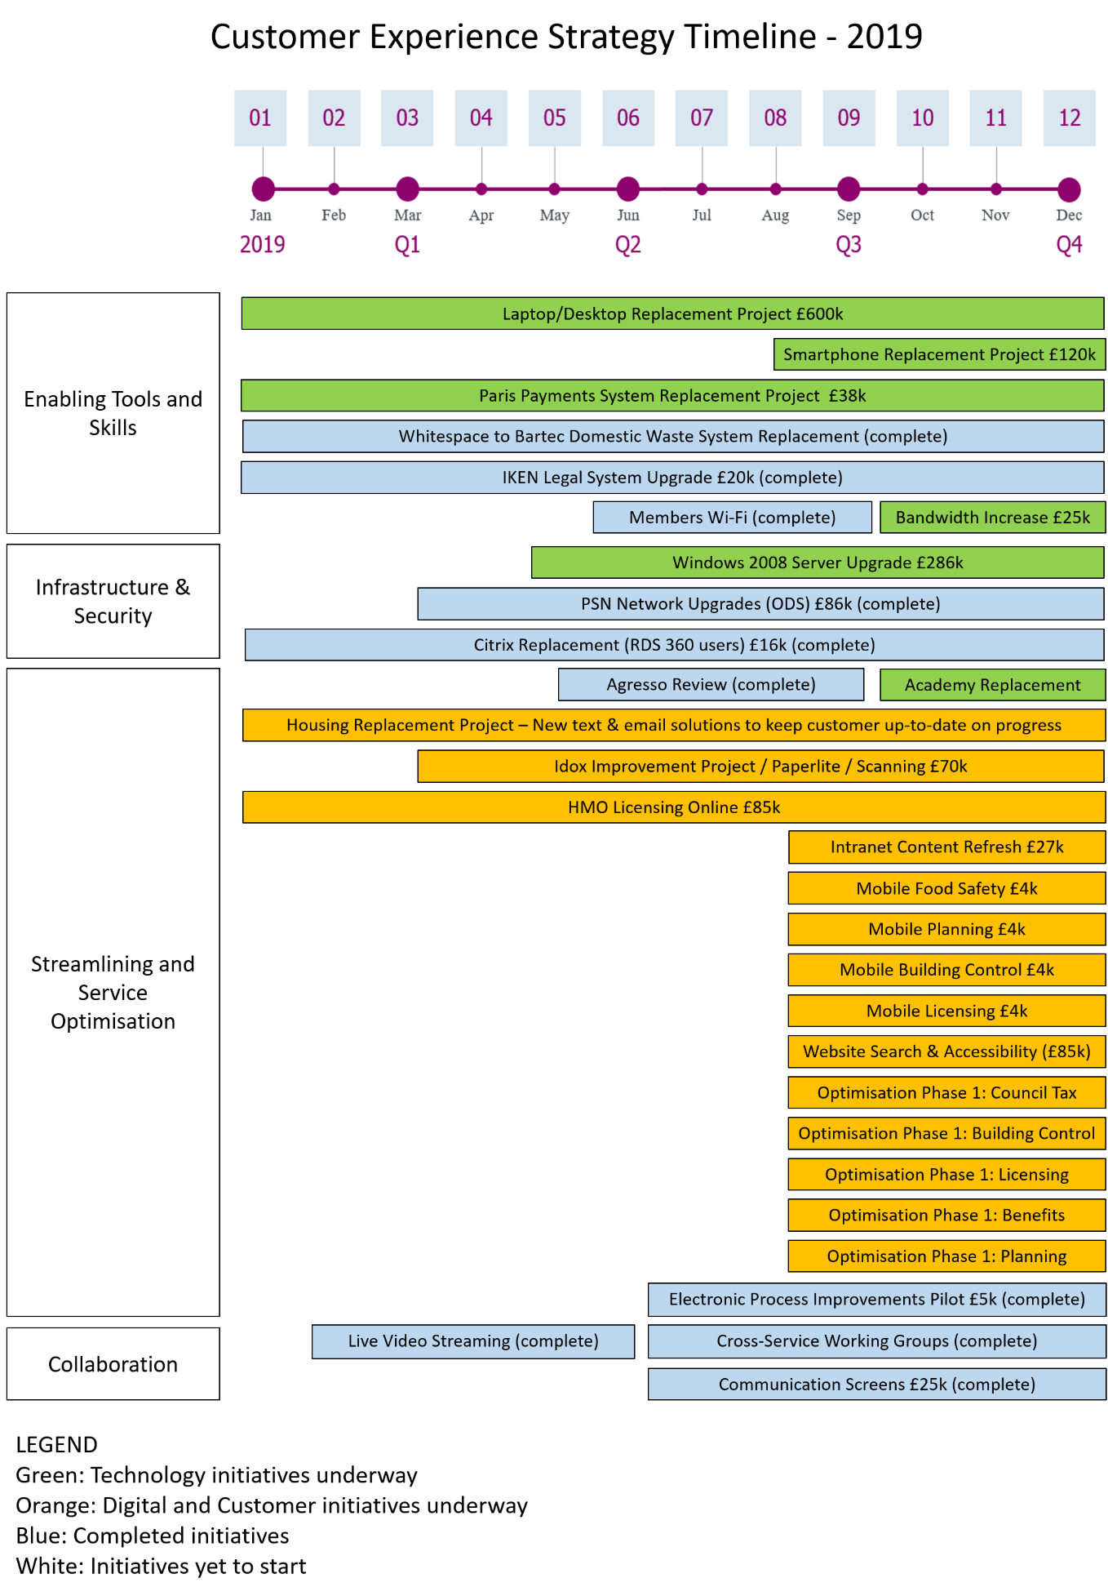
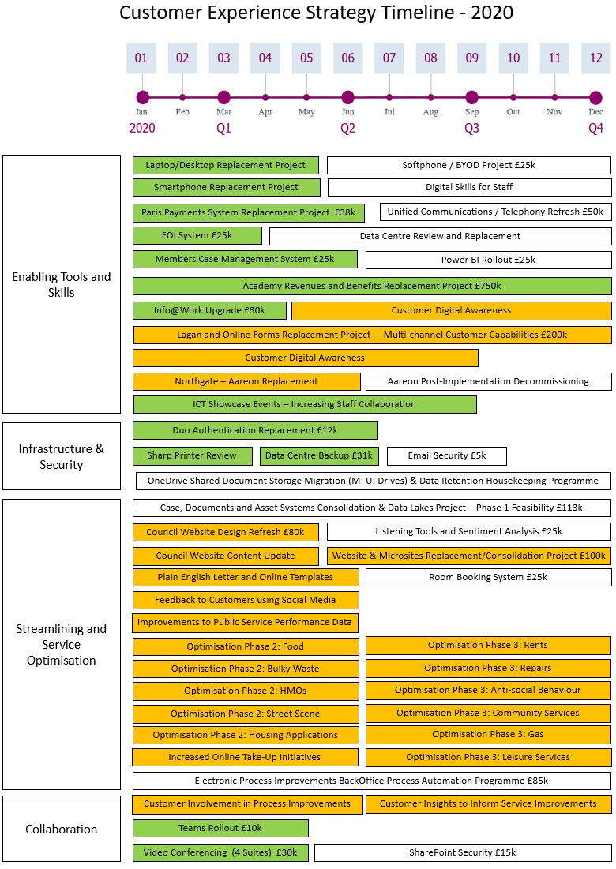

References

- UK Government Digital Strategy
  - https://www.gov.uk/government/publications/uk-digital-strategy
- PSN (Public Services Network)
  - https://www.gov.uk/government/groups/public-services-network
- GOV.UK advice on BYOD
  - https://assets.publishing.service.gov.uk/government/uploads/system/uploads/attachment_data/file/360959/BYOD_Guidance_-_Executive_Summary.pdf
- ICO (Information Commissioners Office) advice on BYOD
  - https://ico.org.uk/media/for-organisations/documents/1563/ico_bring_your_own_device_byod_guidance.pdf
- UK Government Digital Declaration
  - https://localdigital.gov.uk/declaration/
- SOCITM (Society for IT practitioners in the public sector)
  - https://www.socitm.net/
- European Commission – rules for protection of personal data
  - https://ec.europa.eu/info/law/law-topic/data-protection_en

